**E-Commerce Application on IBM Cloud Foundry**

**Phase 2: Innovation**

**Project Objectives**

**To enhance the user experience and satisfaction of our e-commerce application hosted on IBM Cloud Foundry by incorporating innovative features like product reviews, wishlists, and personalized recommendations.**

**1. Product Reviews:**

**Feature Description: Allow users to leave reviews and ratings for products they have purchased.**

**Implementation:**

**Create a review and rating system for each product.**

**Enable users to submit text reviews and a star rating (e.g., 1-5 stars).**

**Display aggregated ratings and individual reviews on product pages.**

**Benefits:**

**User-generated content provides social proof and builds trust.**

**Helps other users make informed purchase decisions.**

**Encourages user engagement and interaction with the platform.**

**2. Wishlists:**

**Feature Description: Enable users to create and manage wishlists of products they want to purchase in the future.**

**Implementation:**

**Allow users to add and remove products from their wishlists.**

**Provide options to make wishlists public or private.**

**Send notifications when wishlisted items are on sale or restocked.**

**Benefits:**

**Increases user retention as they return to check and update their wishlists.**

**Encourages users to share their wishlists, potentially driving more sales.**

**Offers a personalized shopping experience.**

**3. Personalized Recommendations:**

**Feature Description: Utilize user data to provide tailored product recommendations.**

**Implementation:**

**Collect and analyze user behavior data (e.g., browsing history, purchase history).**

**Implement recommendation algorithms (e.g., collaborative filtering, content-based filtering).**

**Display personalized product suggestions on the homepage and product pages.**

**Benefits:**

**Enhances user engagement by showcasing relevant products.**

**Increases cross-selling and upselling opportunities.**

**Improves the overall shopping experience by reducing search time.**

**4. Data Privacy and Security:**

**Considerations: Ensure the privacy and security of user data, especially for features like reviews and personalized recommendations.**

**Implementation:**

**Implement robust data encryption and access control mechanisms.**

**Comply with data protection regulations (e.g., GDPR, CCPA).**

**Allow users to control their data sharing preferences.**

**5. Testing and User Feedback:**

**Approach: Regularly test and gather user feedback to iterate and improve these features.**

**Feedback Channels: Implement feedback forms, surveys, and user testing sessions.**

**Iterate: Continuously refine the features based on user suggestions and data analysis.**

**6. Performance Optimization:**

**Considerations: Ensure that the application remains responsive and performs well with the addition of these features.**

**Implementation:**

**Optimize database queries for reviews and recommendations.**

**Use caching to reduce load times.**

**Monitor application performance and scale resources as needed.**

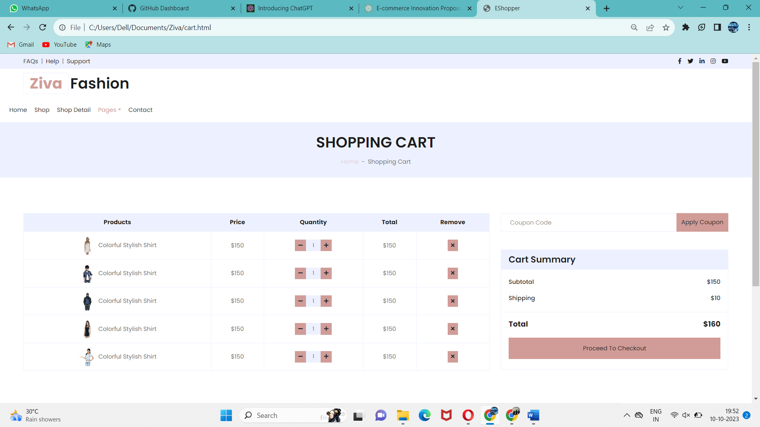

**Pic 1: Sample Cart Page**

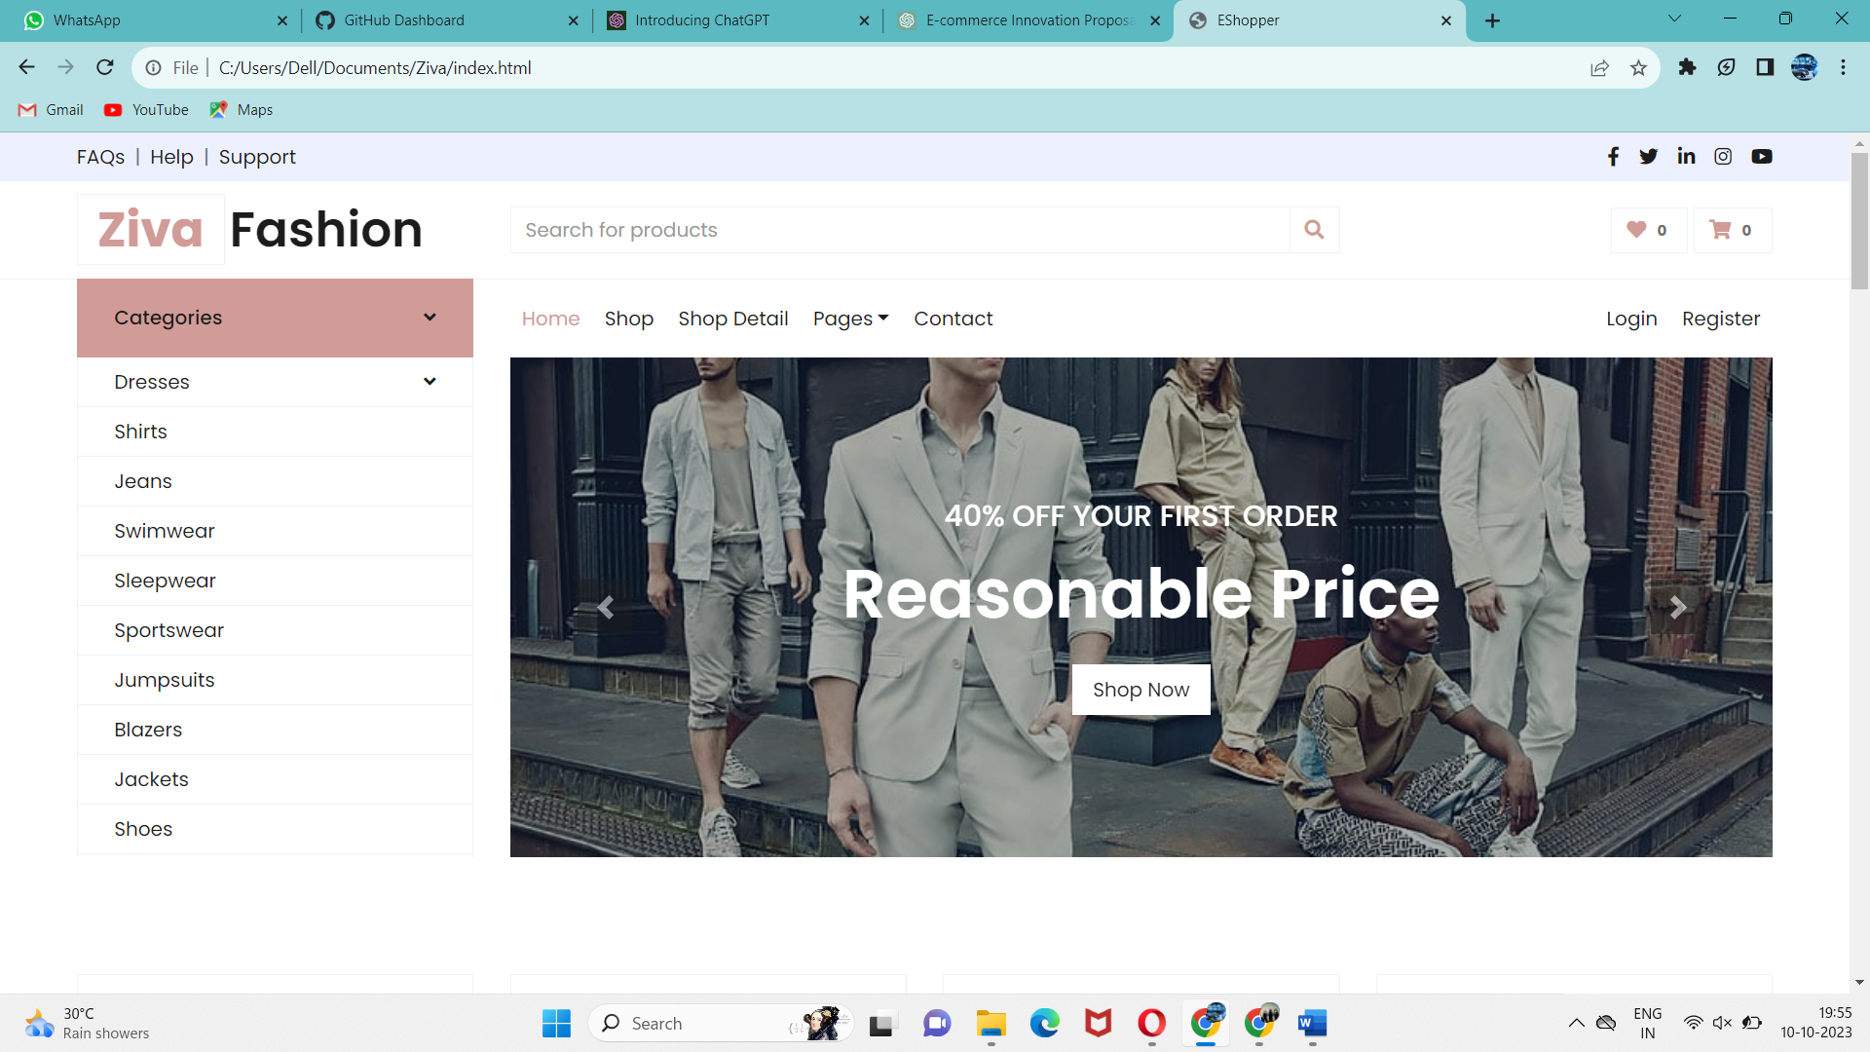

**Pic 2: Sample Home Page** (details of product wishlist etc..)

**Implementation:**

Features for the e-commerce application hosted on IBM Cloud Foundry, we need a structured approach. Below are the detailed steps that will be taken to implement the proposed design

**Step 1: Requirement Refinement and Planning**

Review and refine the requirements for product reviews, wishlists, and personalized recommendations based on stakeholder feedback and any new insights.

Define clear project objectives, scope, and success criteria.

Create a detailed project plan with milestones and timelines.

**Step 2: User Experience (UX) Design**

Collaborate with UX/UI designers to create wireframes and mockups for the new features.

Ensure that the designs align with the existing application's look and feel for a seamless user experience.

Iterate on the designs based on usability testing and feedback.

**Step 3: Technical Design and Architecture**

Define the technical architecture for implementing each feature (reviews, wishlists, recommendations).

Choose appropriate databases and technologies for storing and retrieving user-generated content, wishlist data, and recommendation models.

Plan for scalability and performance optimization.

Develop API specifications for interaction between front-end and back-end components.

**Step 4: Data Management and Storage**

Set up databases or data stores to handle product reviews, wishlist items, and user behavior data for recommendations.

Implement data models and schemas to store relevant information.

Ensure data security and compliance with data protection regulations.

**Step 5: Development**

Develop the back-end services and APIs required for product reviews, wishlists, and personalized recommendations.

Integrate these services with the existing e-commerce application.

Implement user interfaces and front-end components for users to interact with these features.

**Figure:**

